

VIT BHOPAL UNIVERSITY
School of Computing Science and Engineering
Bhopal-Indore Highway, Kothrikalan, Sehore
Madhya Pradesh - 466114

CSA1021 INTRODUCTION TO PROBLEM SOLVING AND PROGRAMMING

REG.NO :26MIP10103
NAME :MUSKAN KUMARI
BRANCH :Int Mtech
SEMESTER: Fall Semester 2026-27

INDEX
Ex.NO | DATE | EXPERIMENT NAME | PAGE NO.
1 | 26-09-26 | To-do-list management system
2 |  | Aim
3 |  | Algorithm
4 |  | flowchart
5 |  | pseudocode
6 |  | Program
7 |  | output
8 |  | result
9
10
11
12
13
14
15
16
17

EXP.NO: 01 | To do list management system  27-09-2026
DATE: | To do list management system  27-09-2026

AIM

To develop a menu-driven To-Do List Management System using Python. The program stores tasks in a list of dictionaries and lets the user add, view, update, delete, search, and complete tasks. It also supports task priorities, status filters, task counts, completion percentage, and a summary.

ALGORITHM

1. Start the program.
2. Create an empty list named tasks.
3. Display the project title and introduction.
4. Ask the user for their name. If it is blank, use "User".
5. Repeat these steps until the user selects Exit:
1. Display the main menu.
2. Ask the user to enter a menu choice.
3. If the choice is Add Task:
- Ask for the task title, category, and priority.
- Create a task dictionary with a number and a "Pending" status.
- Add the dictionary to tasks.
4. If the choice is Display All Tasks, display every task.
5. If the choice is Count All Tasks, display the total number of tasks.
6. If the choice is Count Pending Tasks, count and display pending tasks.
7. If the choice is Count Completed Tasks, count and display completed tasks.
8. If the choice is Complete a Task:
- Ask for a task number.
- Find the task and change its status to "Completed".
9. If the choice is Update a Task:
- Ask for a task number.
- Let the user update its title, category, or priority.
10. If the choice is Delete a Task:
- Ask for a task number.
- Remove the task and renumber the remaining tasks.
11. If the choice is Display Pending Tasks, display only pending tasks.
12. If the choice is Display Completed Tasks, display only completed tasks.
13. If the choice is Search Tasks, find tasks containing the search word in their title or category.
14. If the choice is Filter Tasks by Priority, display tasks with the selected priority.
15. If the choice is Completion Percentage, calculate and display the completed-task percentage.
16. If the choice is Task Summary, display total, pending, completed, and percentage values.
17. If the choice is Remove Completed Tasks, ask for confirmation, remove completed tasks, and renumber the rest.
18. If the choice is Exit, display a goodbye message and stop the loop.
19. If the choice is invalid, display an error message.
6. End the program.

FLOWCHART

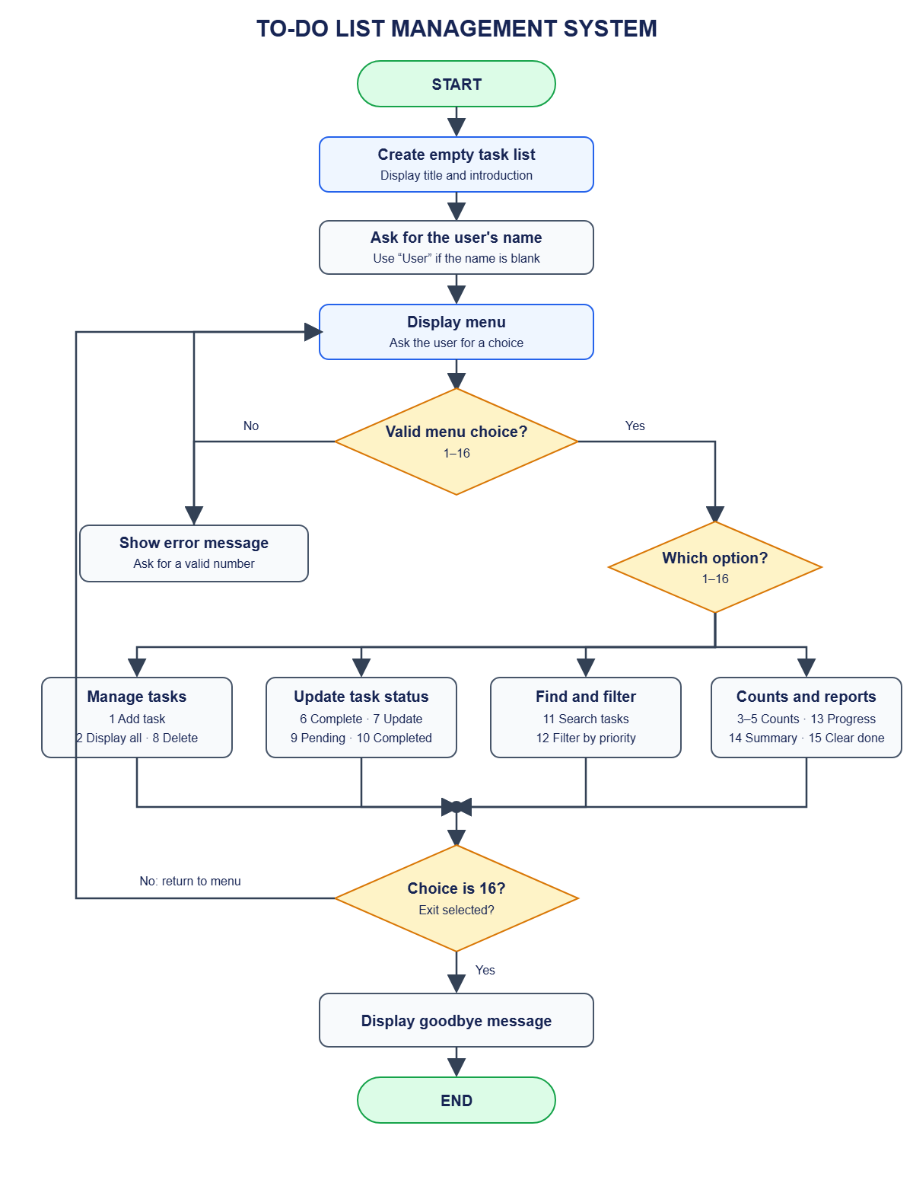

PSEUDO CODE

BEGIN

CREATE empty list tasks

DISPLAY project title
DISPLAY introduction

INPUT user_name

IF user_name is empty THEN
SET user_name to "User"
END IF

DISPLAY greeting using user_name

SET running to TRUE

WHILE running is TRUE

DISPLAY menu
INPUT choice

IF choice is not a whole number THEN
DISPLAY "Please enter a valid whole number"

ELSE

CONVERT choice to integer

IF choice = 1 THEN
INPUT task title
INPUT task category
INPUT task priority
CREATE task dictionary
SET task status to "Pending"
ADD task dictionary to tasks
DISPLAY success message

ELSE IF choice = 2 THEN
DISPLAY every task in tasks

ELSE IF choice = 3 THEN
DISPLAY the number of tasks

ELSE IF choice = 4 THEN
COUNT tasks with status "Pending"
DISPLAY pending count

ELSE IF choice = 5 THEN
COUNT tasks with status "Completed"
DISPLAY completed count

ELSE IF choice = 6 THEN
INPUT task number
FIND task with that number

IF task is found THEN
IF task status is "Pending" THEN
SET task status to "Completed"
DISPLAY success message
ELSE
DISPLAY "Task is already completed"
END IF
ELSE
DISPLAY "Task number not found"
END IF

ELSE IF choice = 7 THEN
INPUT task number
FIND task with that number

IF task is found THEN
DISPLAY update options
INPUT update choice

IF update choice is title THEN
INPUT new title
UPDATE task title
ELSE IF update choice is category THEN
INPUT new category
UPDATE task category
ELSE IF update choice is priority THEN
INPUT new priority
UPDATE task priority
ELSE
DISPLAY "Update cancelled or invalid"
END IF
ELSE
DISPLAY "Task number not found"
END IF

ELSE IF choice = 8 THEN
INPUT task number
FIND task with that number

IF task is found THEN
REMOVE task from tasks
RENUMBER remaining tasks
DISPLAY success message
ELSE
DISPLAY "Task number not found"
END IF

ELSE IF choice = 9 THEN
DISPLAY tasks with status "Pending"

ELSE IF choice = 10 THEN
DISPLAY tasks with status "Completed"

ELSE IF choice = 11 THEN
INPUT search word
SEARCH task titles and categories
DISPLAY matching tasks

ELSE IF choice = 12 THEN
INPUT priority
DISPLAY tasks with that priority

ELSE IF choice = 13 THEN
COUNT all tasks
COUNT completed tasks

IF total task count is zero THEN
SET percentage to 0
ELSE
CALCULATE completed count * 100 / total count
END IF

DISPLAY completion percentage

ELSE IF choice = 14 THEN
COUNT all tasks
COUNT pending tasks
COUNT completed tasks
CALCULATE completion percentage
DISPLAY task summary

ELSE IF choice = 15 THEN
COUNT completed tasks

IF completed task count is greater than zero THEN
ASK user to confirm

IF user confirms THEN
REMOVE completed tasks
RENUMBER remaining tasks
DISPLAY success message
ELSE
DISPLAY "No tasks were removed"
END IF
ELSE
DISPLAY "There are no completed tasks"
END IF

ELSE IF choice = 16 THEN
DISPLAY goodbye message
SET running to FALSE

ELSE
DISPLAY "Invalid menu choice"
END IF

END IF
END WHILE
END
PROGRAM

# A task starts with Pending status and can later become Completed.
# Task numbers are updated after individual or bulk deletion.
# Searches ignore capitalization in titles and categories.
# The menu repeats until the user chooses the Exit option.
# ================================================================
# TO-DO LIST MANAGEMENT SYSTEM
# ================================================================
# Manage tasks with beginner Python concepts: lists, dictionaries,
# functions, loops, conditions, input, output, and counting.
# Features include adding, viewing, updating, deleting, searching,
# priority selection, status filters, and completion summaries.
# ================================================================

# This list stores task dictionaries while the program is running.
tasks = []

# Display the project title when the program starts.
def display_title():
"""Display the application title."""
print("=" * 52)
print(" TO-DO LIST MANAGEMENT SYSTEM")
print("=" * 52)
print(" PYTHON MINI PROJECT")
print("=" * 52)
print()

def display_introduction():
"""Explain the program to the user."""
print("Welcome to the To-Do List Management System.")
print("Use the menu to organize your tasks.")
print("Each task has a number, title, category, priority,")
print("and status.")
print()

def get_user_name():
"""Ask for a name and return a default if it is blank."""
name = input("Enter your name: ").strip()
if name == "":
print("No name was entered, so the name User will be used.")
name = "User"
return name

def get_non_empty_text(prompt):
"""Keep asking until the user enters non-empty text."""
value = input(prompt).strip()
while value == "":
print("This value cannot be empty.")
value = input(prompt).strip()

return value

def get_task_number(prompt):
"""Read a positive task number from the user."""
number_text = input(prompt).strip()
while not number_text.isdigit() or int(number_text) < 1:
print("Enter a positive whole number.")
number_text = input(prompt).strip()

return int(number_text)

def choose_priority():
"""Ask the user to choose a task priority."""
print()
print("Choose a priority:")
print("1. High")
print("2. Medium")
print("3. Low")
choice = input("Enter priority choice: ").strip()

while choice not in ["1", "2", "3"]:
print("Choose 1, 2, or 3.")
choice = input("Enter priority choice: ").strip()
if choice == "1":
return "High"
elif choice == "2":
return "Medium"
else:
return "Low"

def create_task(title, category, priority):
"""Create a task dictionary and return it."""
task = {
"number": len(tasks) + 1,
"title": title,
"category": category,
"priority": priority,
"status": "Pending"
}

return task

def add_task():
"""Ask for task information and save a new task."""
print()
print("---------------- ADD TASK ----------------")
title = get_non_empty_text("Enter the task: ")
category = get_non_empty_text("Enter a category: ")
priority = choose_priority()

new_task = create_task(title, category, priority)
tasks.append(new_task)
print()
print("Task added successfully.")
print_task(new_task)
print()

def print_task(task):
"""Print the fields of one task in a consistent format."""
print("Task Number :", task["number"])
print("Task Name :", task["title"])
print("Category :", task["category"])
print("Priority :", task["priority"])
print("Status :", task["status"])
print("-" * 45)

def display_tasks():
"""Display every task."""
print()
print("---------------- ALL TASKS ----------------")

if len(tasks) == 0:
print("There are no tasks.")
print()
return
print("Total tasks:", len(tasks))
print()

for task in tasks:
print_task(task)
print()

def find_task(task_number):
"""Return the matching task dictionary, or None."""
for task in tasks:
if task["number"] == task_number:
return task

return None

def show_task_not_found():
"""Print a standard message when a task is missing."""
print("Task number not found.")
print()

def ask_for_existing_task():
"""Ask for a task number and return the matching task."""
if len(tasks) == 0:
print("There are no tasks available.")
return None
display_tasks()
number = get_task_number("Enter a task number: ")
task = find_task(number)

if task is None:
show_task_not_found()
return task

def complete_task():
"""Change a pending task's status to Completed."""
print()
print("---------------- COMPLETE TASK ----------------")

task = ask_for_existing_task()
if task is None:
return

if task["status"] == "Completed":
print("This task is already completed.")
else:
task["status"] = "Completed"
print("Task marked as completed.")
print_task(task)
print()

def update_task():
"""Update the title, category, or priority of a task."""
print()
print("---------------- UPDATE TASK ----------------")

task = ask_for_existing_task()
if task is None:
return

print("Current task:")
print_task(task)
print("What would you like to update?")
print("1. Task title")
print("2. Category")
print("3. Priority")
print("4. Cancel")
choice = input("Enter your choice: ").strip()

if choice == "1":
task["title"] = get_non_empty_text("Enter the new title: ")
print("Task title updated.")
elif choice == "2":
task["category"] = get_non_empty_text("Enter the new category: ")
print("Category updated.")
elif choice == "3":
task["priority"] = choose_priority()
print("Priority updated.")
elif choice == "4":
print("Update cancelled.")
else:
print("Invalid update choice.")
print()

def delete_task():
"""Remove one selected task from the list."""
print()
print("---------------- DELETE TASK ----------------")

task = ask_for_existing_task()
if task is None:
return

removed_title = task["title"]
tasks.remove(task)
renumber_tasks()
print("Task deleted:", removed_title)
print()

def renumber_tasks():
"""Give tasks consecutive numbers after a deletion."""
number = 1

for task in tasks:
task["number"] = number
number = number + 1

def count_tasks():
"""Display and return the total task count."""
total = len(tasks)
print()
print("---------------- TASK COUNT ----------------")
print("Total tasks:", total)
print()

return total

def count_tasks_with_status(status):
"""Count tasks whose status matches the given value."""
count = 0
for task in tasks:
if task["status"] == status:
count = count + 1

return count

def count_pending_tasks():
"""Display the number of pending tasks."""
pending = count_tasks_with_status("Pending")
print()
print("Pending tasks:", pending)
print()

return pending

def count_completed_tasks():
"""Display the number of completed tasks."""
completed = count_tasks_with_status("Completed")
print()
print("Completed tasks:", completed)
print()

return completed

def display_tasks_with_status(status):
"""Display tasks matching a status."""
print()
print("----------------", status.upper(), "TASKS ----------------")
matching_count = 0

for task in tasks:
if task["status"] == status:
print_task(task)
matching_count = matching_count + 1
if matching_count == 0:
print("There are no", status.lower(), "tasks.")

print("Total", status.lower(), "tasks:", matching_count)
print()

def display_pending_tasks():
"""Display only pending tasks."""
display_tasks_with_status("Pending")

def display_completed_tasks():
"""Display only completed tasks."""
display_tasks_with_status("Completed")

def display_tasks_by_priority(priority):
"""Display tasks that have the selected priority."""
print()
print("----------------", priority.upper(), "PRIORITY TASKS ----------------")
matching_count = 0

for task in tasks:
if task["priority"] == priority:
print_task(task)
matching_count = matching_count + 1
if matching_count == 0:
print("There are no", priority.lower(), "priority tasks.")

print("Matching tasks:", matching_count)
print()

def filter_tasks_by_priority():
"""Let the user select a priority filter."""
print()
print("---------------- FILTER BY PRIORITY ----------------")
priority = choose_priority()
display_tasks_by_priority(priority)

def search_tasks():
"""Find tasks whose title or category contains a word."""
print()
print("---------------- SEARCH TASKS ----------------")
if len(tasks) == 0:
print("There are no tasks to search.")
print()
return

search_text = get_non_empty_text("Enter a word to search for: ")
search_text = search_text.lower()
found_count = 0
for task in tasks:
title_matches = search_text in task["title"].lower()
category_matches = search_text in task["category"].lower()

if title_matches or category_matches:
print_task(task)
found_count = found_count + 1
if found_count == 0:
print("No tasks matched your search.")

print("Matching tasks:", found_count)
print()

def completion_percentage():
"""Calculate and display the completed-task percentage."""
total = len(tasks)
completed = count_tasks_with_status("Completed")
print()
print("---------------- COMPLETION ----------------")

if total == 0:
print("There are no tasks.")
print("Completion percentage: 0%")
else:
percentage = completed * 100 / total
print("Total tasks:", total)
print("Completed tasks:", completed)
print("Completion percentage:", round(percentage, 2), "%")
print()

def remove_completed_tasks():
"""Remove all completed tasks from the list."""
print()
print("---------------- CLEAR COMPLETED TASKS ----------------")

completed_count = count_tasks_with_status("Completed")
if completed_count == 0:
print("There are no completed tasks to remove.")
print()
return

print("Completed tasks to remove:", completed_count)
answer = input("Remove them? Enter Y to confirm: ").strip().lower()
if answer == "y":
remaining_tasks = []

for task in tasks:
if task["status"] != "Completed":
remaining_tasks.append(task)
tasks.clear()

for task in remaining_tasks:
tasks.append(task)
renumber_tasks()
print("Completed tasks removed.")
else:
print("No tasks were removed.")

print()

def task_summary():
"""Display totals and completion percentage."""
total = len(tasks)
pending = count_tasks_with_status("Pending")
completed = count_tasks_with_status("Completed")
if total == 0:
percentage = 0
else:
percentage = completed * 100 / total

print()
print("=" * 52)
print(" TASK SUMMARY")
print("=" * 52)
print("Total tasks :", total)
print("Pending tasks :", pending)
print("Completed tasks :", completed)
print("Completion :", round(percentage, 2), "%")
print("=" * 52)
print()

def display_menu():
"""Display all available commands."""
print()
print("=" * 52)
print("MAIN MENU")
print("=" * 52)
print("1. Add Task")
print("2. Display All Tasks")
print("3. Count All Tasks")
print("4. Count Pending Tasks")
print("5. Count Completed Tasks")
print("6. Complete a Task")
print("7. Update a Task")
print("8. Delete a Task")
print("9. Display Pending Tasks")
print("10. Display Completed Tasks")
print("11. Search Tasks")
print("12. Filter Tasks by Priority")
print("13. Completion Percentage")
print("14. Task Summary")
print("15. Remove Completed Tasks")
print("16. Exit")
print("=" * 52)

def process_choice(choice):
"""Run the function selected by the user."""
if choice == 1:
add_task()
elif choice == 2:
display_tasks()
elif choice == 3:
count_tasks()
elif choice == 4:
count_pending_tasks()
elif choice == 5:
count_completed_tasks()
elif choice == 6:
complete_task()
elif choice == 7:
update_task()
elif choice == 8:
delete_task()
elif choice == 9:
display_pending_tasks()
elif choice == 10:
display_completed_tasks()
elif choice == 11:
search_tasks()
elif choice == 12:
filter_tasks_by_priority()
elif choice == 13:
completion_percentage()
elif choice == 14:
task_summary()
elif choice == 15:
remove_completed_tasks()
elif choice == 16:
print()
print("Thank you for using the To-Do List.")
print("Program closed successfully.")
print()
return False
else:
print()
print("Invalid choice. Select a number from 1 to 16.")
print()
return True

def main():
"""Display the welcome screen and run the menu loop."""
display_title()
display_introduction()

user_name = get_user_name()
print()
print("Hello", user_name + "!")
print("Your To-Do List is ready.")

running = True
while running:
display_menu()
choice_text = input("Enter your choice: ").strip()

if choice_text.isdigit():
choice = int(choice_text)
running = process_choice(choice)
else:
print()
print("Please enter a valid whole number.")
print()

# Start the program.
main()
# ================================================================
# END OF PROGRAM
# ================================================================

OUTPUT

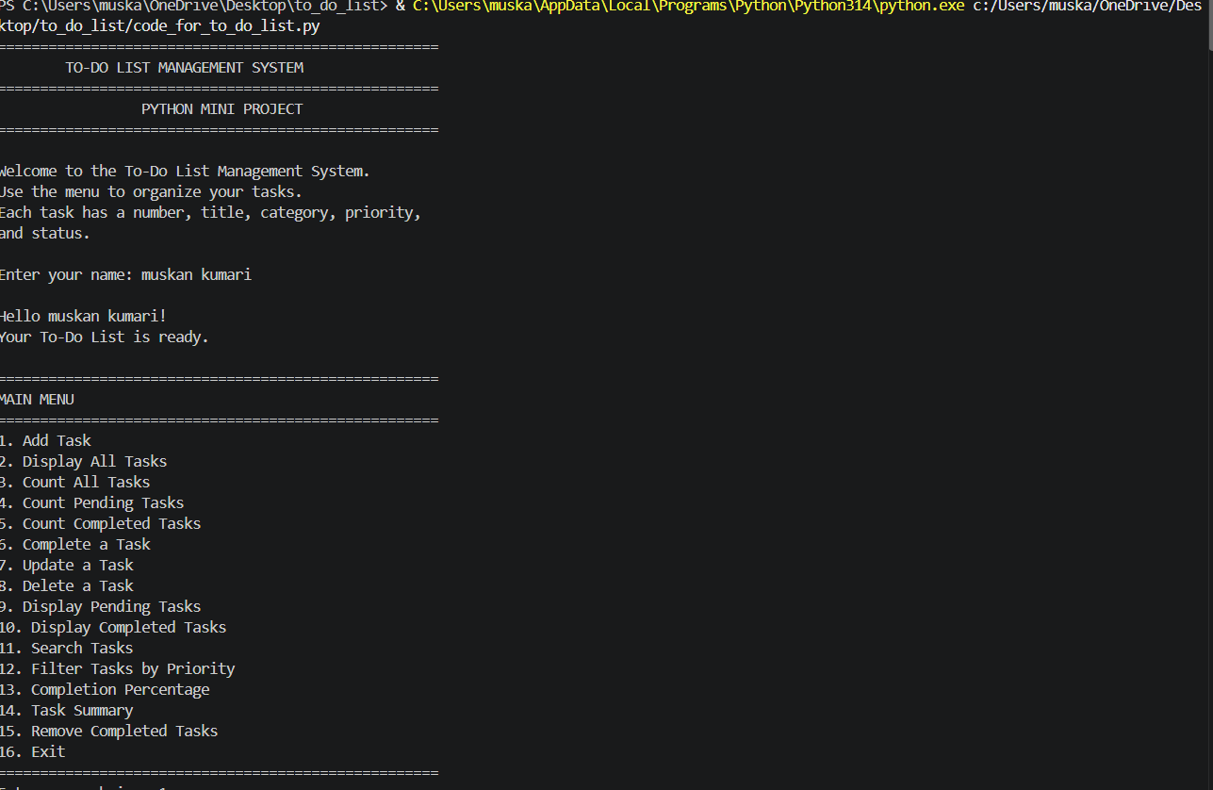

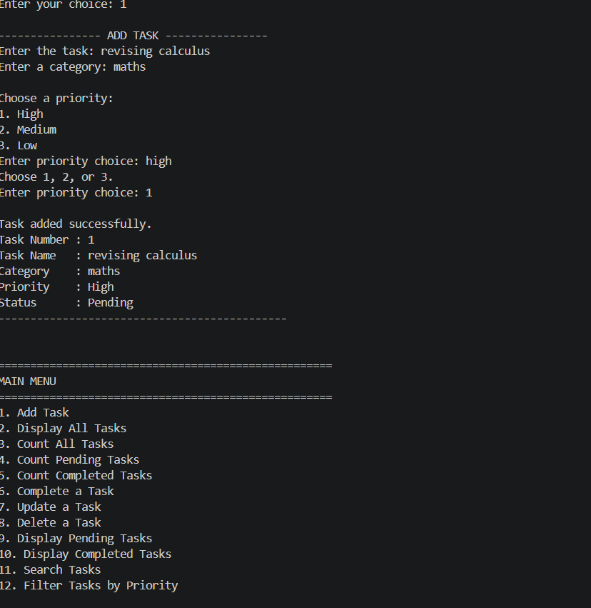

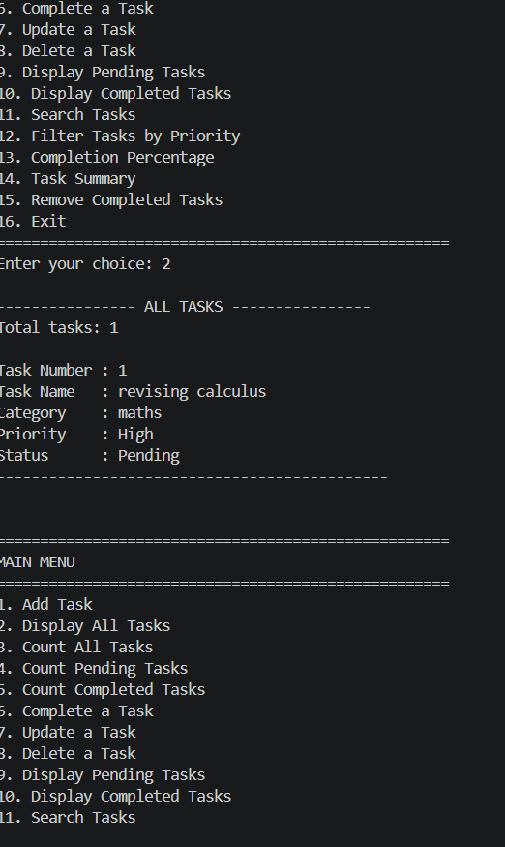

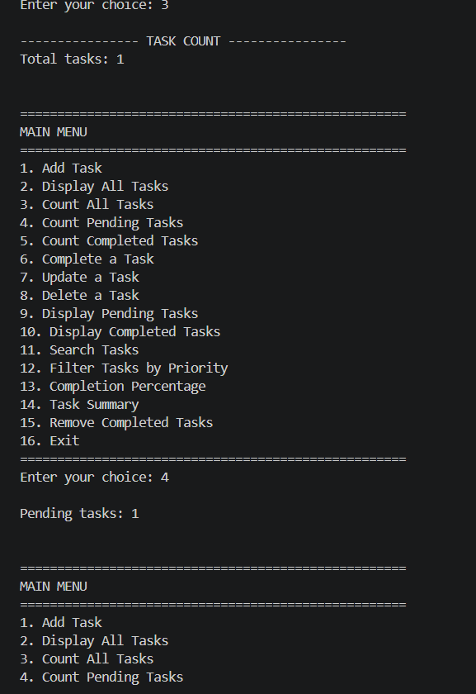

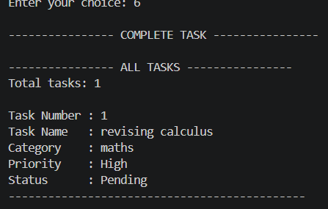

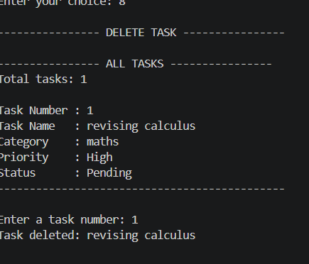

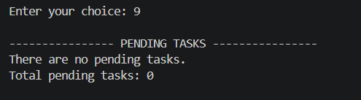

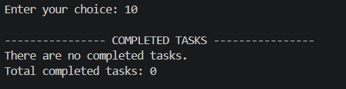

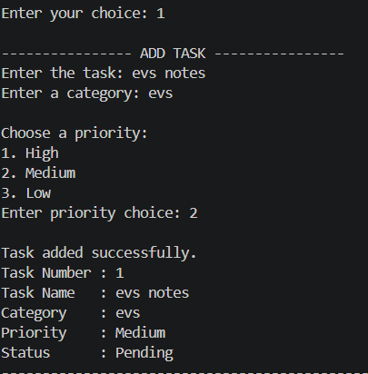
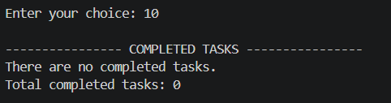

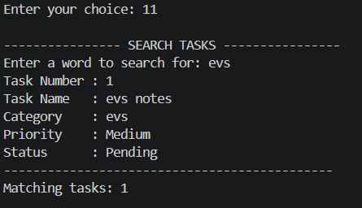

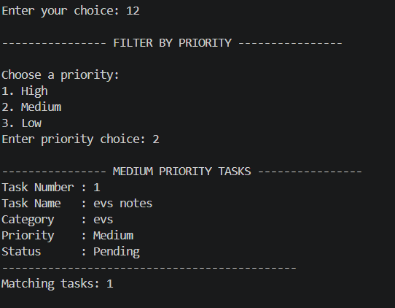

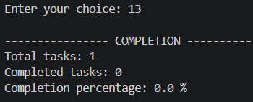

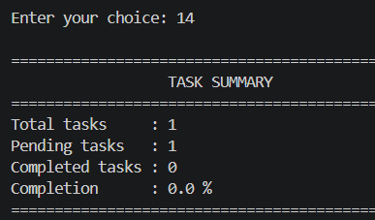

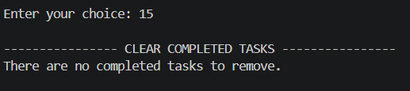

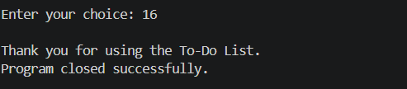

Result

The To-Do List Management System was successfully developed using Python. It allows users to add, view, update, delete, search, and complete tasks. The program also supports task priorities, status filters, task counts, and completion summaries. The project demonstrates the use of lists, dictionaries, functions, loops, and conditional statements in a practical application.

